1.Create a table called Playlist with columns: id, song_name, artist, genre, and play_count. Insert at least 5 sample records representing your favorite songs from Spotify.
ANS:
QUERY:
CREATE TABLE playlist(id int PRIMARY KEY,song_name varchar(100),artist varchar(100), genre varchar(50),play_count int);
INSERT INTO playlist (id,song_name,artist,genre,play_count) values(1,'Zara sa','KK','Relax','200'),(2,'Tera Yaar Hoon Mein','Arjit singh','bollywood acoustic','180'),(3,'Dil Dhadakne Do','Vishal daldalani','pop rock','150'),(4,'Yeh shaam mastani','Kishor kumar','sunset retro','120'),(5,'Blinding lights','the weekend','pop','80');
SELECT * FROM playlist;
Output:
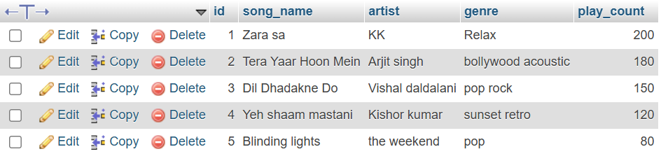
Q.2. Write a SELECT query to display only the song_name and artist from the Playlist table, but show the artist column as 'Singer' using an alias.
ANS:
Query:
SELECT song_name, artist AS singer FROM playlist;
Output:
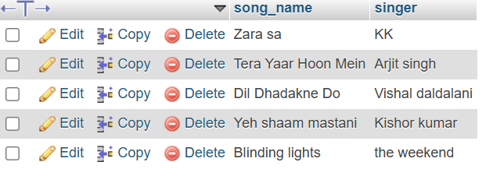
Q.3. Write a SELECT query to find all songs in the Playlist table where the genre is 'Pop' and play_count is greater than 100. Sort the results by play_count in descending order.
ANS:
Query:
SELECT * FROM playlist WHERE genre = 'pop' AND play_count > 100 ORDER BY play_count DESC;
Output:
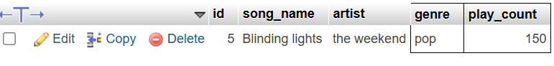
4.Use the COUNT aggregate function to find out how many songs in your Playlist table belong to the genre 'Hip-Hop'.
ANS:
Query:
UPDATE playlist SET genre = 'hip hop' WHERE song_name = 'Dil dhadakne Do';
SELECT * FROM playlist; SELECT COUNT(*) AS hip_hop_songs FROM playlist WHERE genre = 'hip hop';
Output:
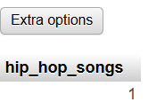
Q.5. Write a SELECT query that shows the total number of plays (SUM of play_count) for each genre in your Playlist table, grouped by genre.
ANS:
Query:
SELECT genre, SUM(play_count) AS total_plays FROM playlist GROUP BY genre;
 |  |  |  | genre | total_plays
 | Edit | Copy | Delete | bollywood acoustic | 180
 | Edit | Copy | Delete | hip hop | 150
 | Edit | Copy | Delete | pop | 150
 | Edit | Copy | Delete | Relax | 200
 | Edit | Copy | Delete | sunset retro | 120

